TIFF

📘 Definition
# Source: AI Source: Provided by: [Data Path: Persons Table -> ID Column: 1, Name_En Column: Motasem Essam] -> From: [ChatGPT] on [5/2/2026]
TIFF is a high-quality image file format used to store detailed images without losing quality. It is mainly used in professional photography, printing, and publishing.

📸 How TIFF works
# Source: AI Source: Provided by: [Data Path: Persons Table -> ID Column: 1, Name_En Column: Motasem Essam] -> From: [ChatGPT] on [5/2/2026]
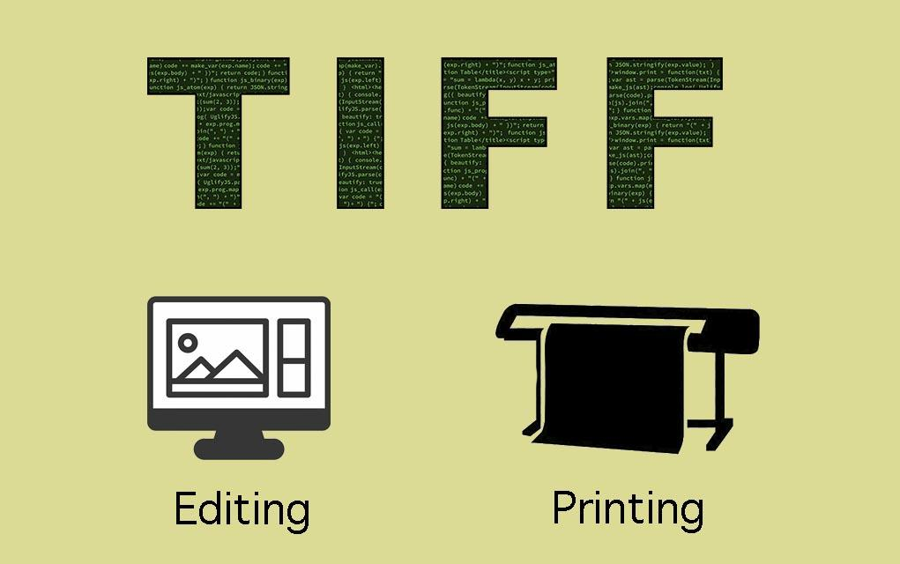
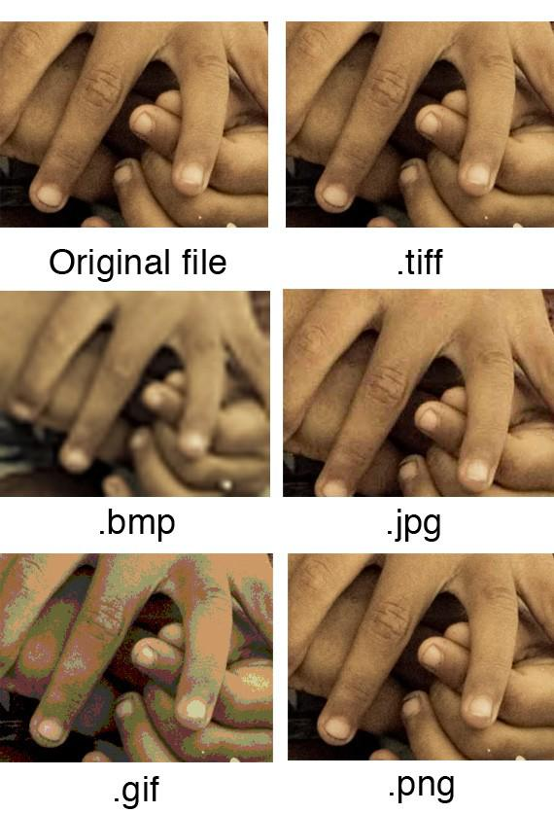
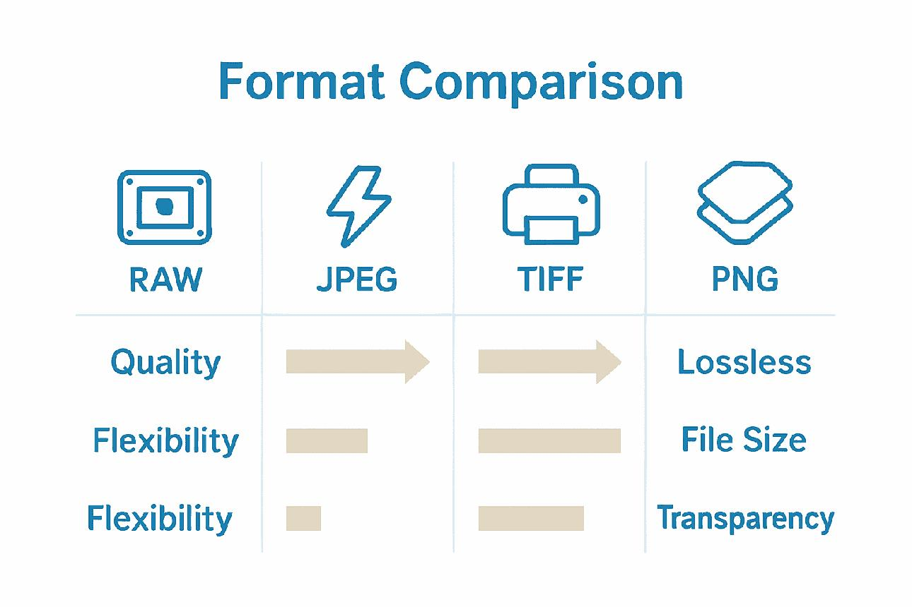
- Stores images using lossless compression (or no compression)
- Keeps very high detail and color accuracy
- Produces large file sizes
- Designed for editing and printing

🧠 Simple example
# Source: AI Source: Provided by: [Data Path: Persons Table -> ID Column: 1, Name_En Column: Motasem Essam] -> From: [ChatGPT] on [5/2/2026]
Think of:
- 🖨️ A high-quality magazine or poster print
- 📷 A professional camera image used for editing
- 🖌️ A scanned artwork saved without losing detail
These are often saved as TIFF files.

🎨 Where TIFF is used
# Source: AI Source: Provided by: [Data Path: Persons Table -> ID Column: 1, Name_En Column: Motasem Essam] -> From: [ChatGPT] on [5/2/2026]
- 📸 Professional photography
- 🖨️ Printing industry (posters, books, magazines)
- 🧑‍🎨 Graphic design and editing
- 🏛️ Archiving important images

⚙️ Key features
# Source: AI Source: Provided by: [Data Path: Persons Table -> ID Column: 1, Name_En Column: Motasem Essam] -> From: [ChatGPT] on [5/2/2026]
- 🟢 Very high image quality
- 📁 Large file size
- 🎨 Supports rich colors and details
- ✏️ Ideal for editing and printing

🚀 In short:
# Source: AI Source: Provided by: [Data Path: Persons Table -> ID Column: 1, Name_En Column: Motasem Essam] -> From: [ChatGPT] on [5/2/2026]
TIFF = a high-quality image format used for professional work where maximum detail and accuracy are needed, especially in printing and editing.

